Lab 5 Shared Document

(Abir)

What does it mean to create a variable that refers to a DOM element?

It means we are saving a part of the webpage into a variable, so we can use JavaScript to control it later. For example, if you have a button on the page, you can “catch” that button with JavaScript and put it inside a variable. The variable doesn’t copy the button it just points to it. This way, whenever you use the variable, you are really working with the real button on the webpage.

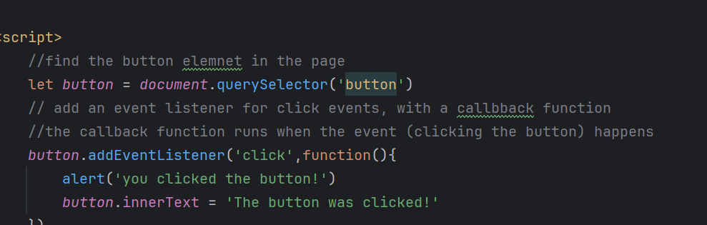

(Ramadan)How can you create a variable like this?

a dom element is a part of a web page, such as a button, heading, or paragraph. when the page loads, javascript can access and control these elements. by using javascript, you can find an element and store it in a variable, which lets you work with it later.

For example,

the code let button = document.getElementById("myButton"); finds the element with the id "myButton" and saves it in a variable named button.

once you've stored a dom element in a variable, you can do many things with it.

you can listen for events, like clicks, using code like button.addEventListener("click", function() { alert("you clicked the button!"); });.

you can also change the element, such as updating its text or color using button.textContent = "clicked!"; or button.style.backgroundColor = "blue";.

this is different from variables that store simple values.

a string variable holds text, like let name = "ramadan";.

a number variable holds a number, like let age = 25;.

but a variable that holds a dom element gives you control over parts of the web page itself.

only dom element variables let you change how the page looks or responds to user actions.

(Tyler)What can you do with this variable?

You can use these variables to change content of the elements using inner.HTML such as: paragraph.innerHTML = "New text here!";

You can change their styles using the .style method such as:

paragraph.style.color = "red";

You can use them to respond to events on the web page using the .addEventListener such as:  
paragraph.addEventListener("click", function() {

paragraph.style.fontSize = "30px";

});